Report ETL

# Task 2. Generate Test Data in Storage Layers

ETL procedures starts with executing pre-configured framework “create_schemas.sql” – for grants to users.

## sa_src

### Creation of directory



1. Creation of external tables

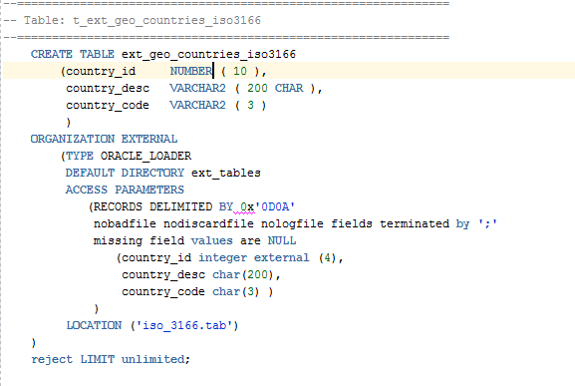

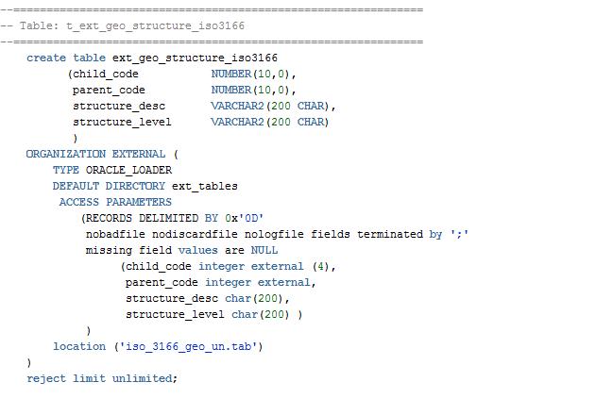

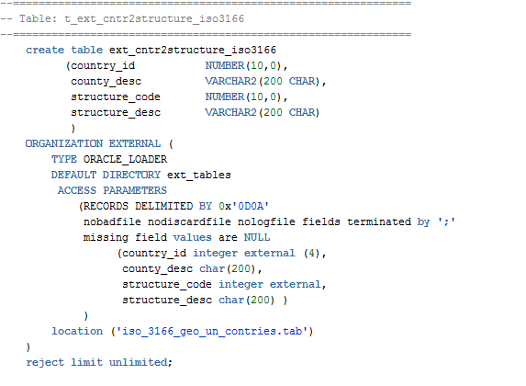

## bl_cl

### Package-Procedure

Pre-configured framework with drop package

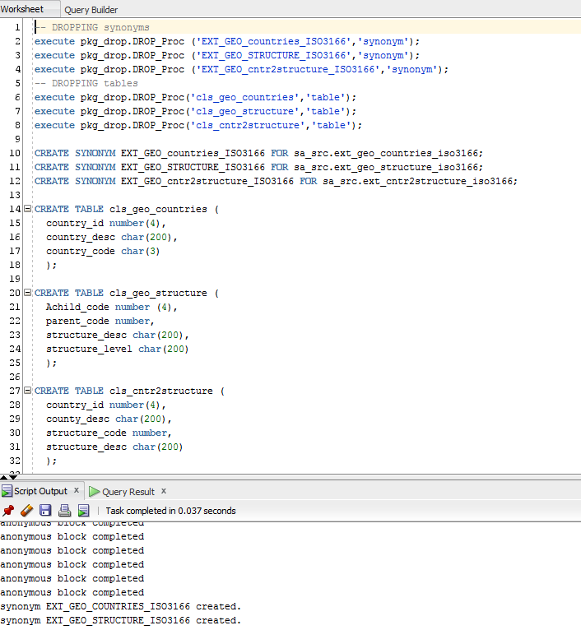

### INSERT package procedure

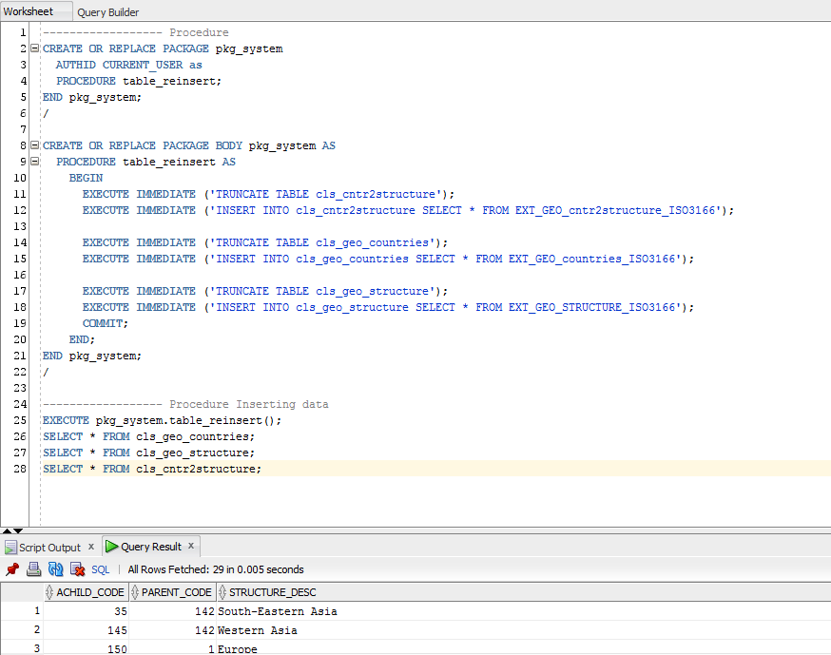

## bl_3nf

### Structure

3nf schema will be consist of 4 tables:

1. World (nf_world);
2. Continents (nf_continents);
3. Regions (nf_regions);
4. Countries (nf_countries).

3 synonyms from bl_cl shema:

1. cls_geo_structure;
2. cls_geo_countries;
3. cls_cntr2structure

And 3 sequences:

1. For World (seq_world);
2. For Continents (seq_continent);
3. For Regions (seq_region).

* Countries do not need autoincremented id because it has “country_id” field.

### Grants

Additional grans should be set to bl_3nf from SYSTEM user:

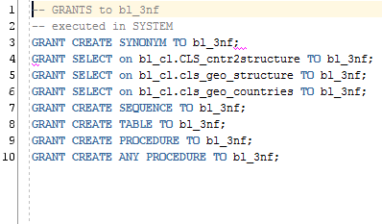

### Package-Procedure

Pre-configured framework with drop package will be also used in bl_3nf:

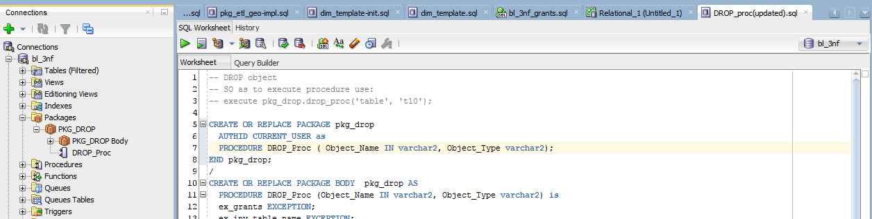

### Building structure

1. Dropping existing objects

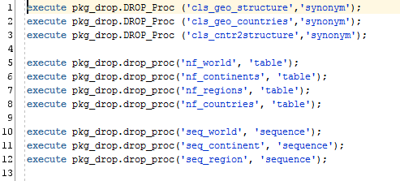

### DDL operations

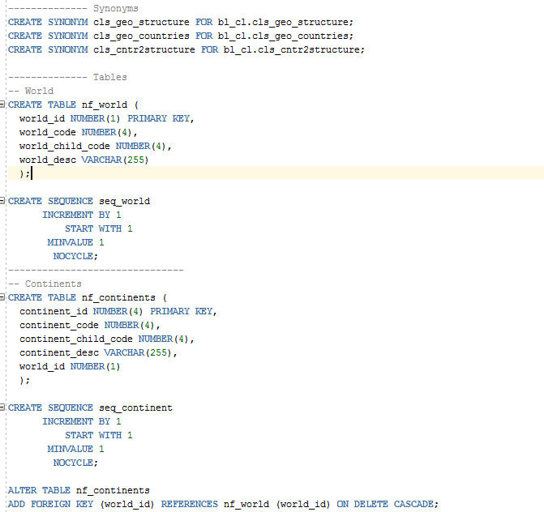

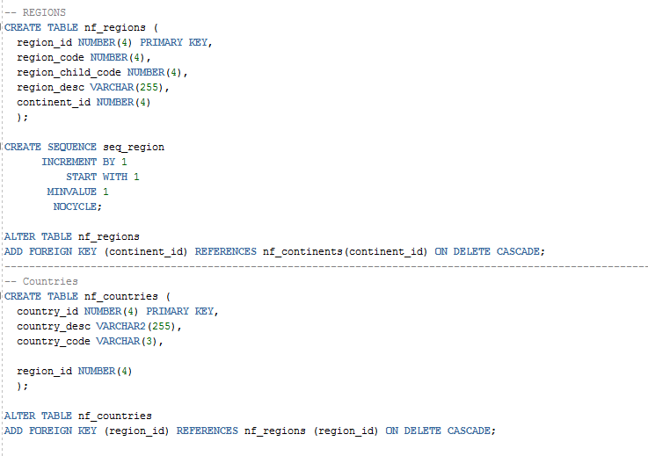

### DML operations in package procedure

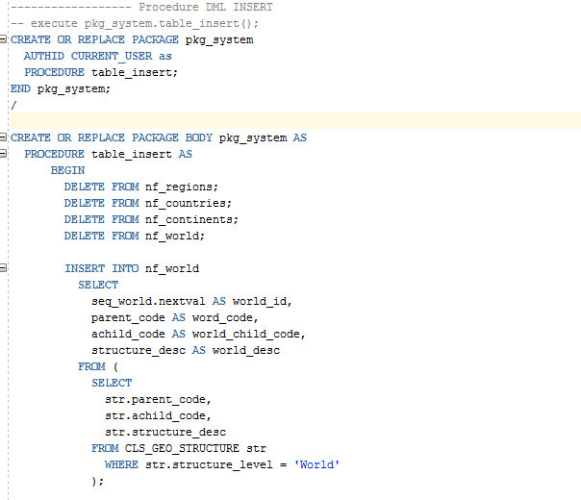

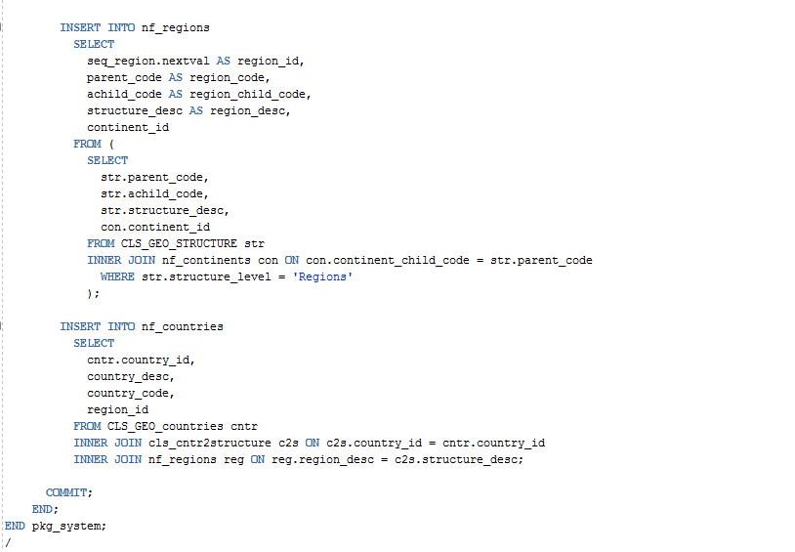

### The result of bl_3nf:

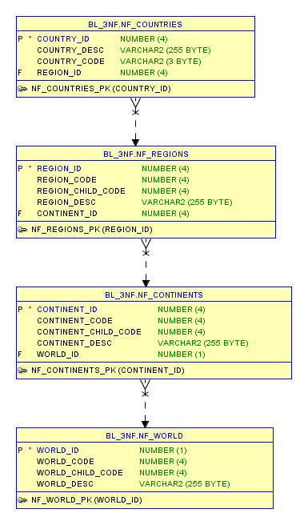

# Task 3. SQL*Plus

In Oracle Terminal:

## Setting autotrace on so as to get execution plan to SYSTEM user



Executing tables

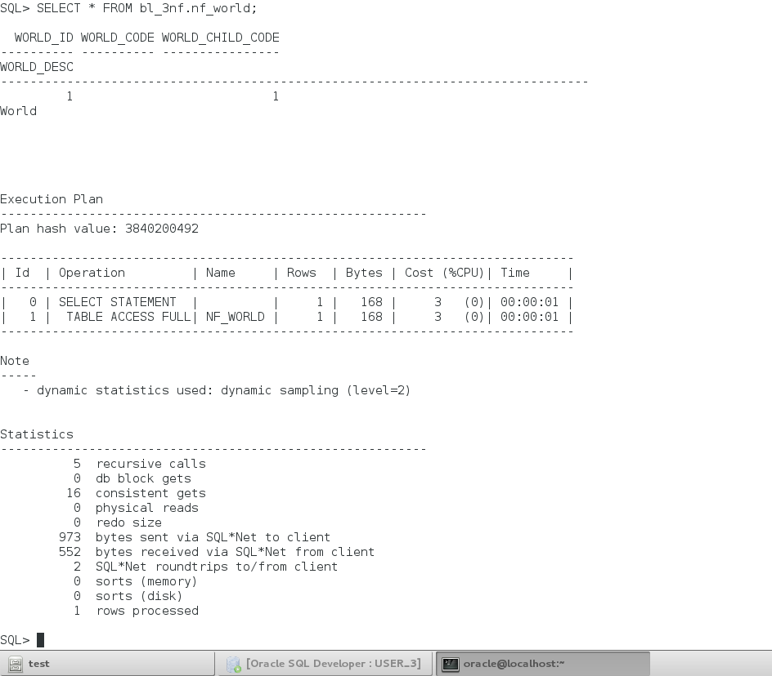

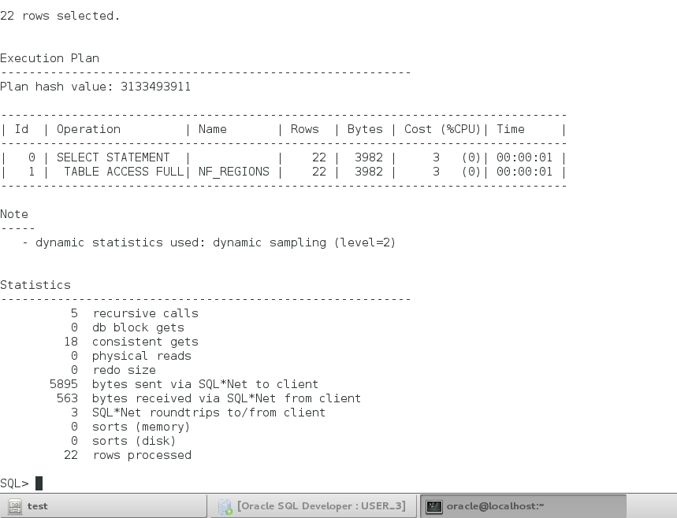

## Timing



Only “countries” table forced Oracle to make some work and elapse some time:

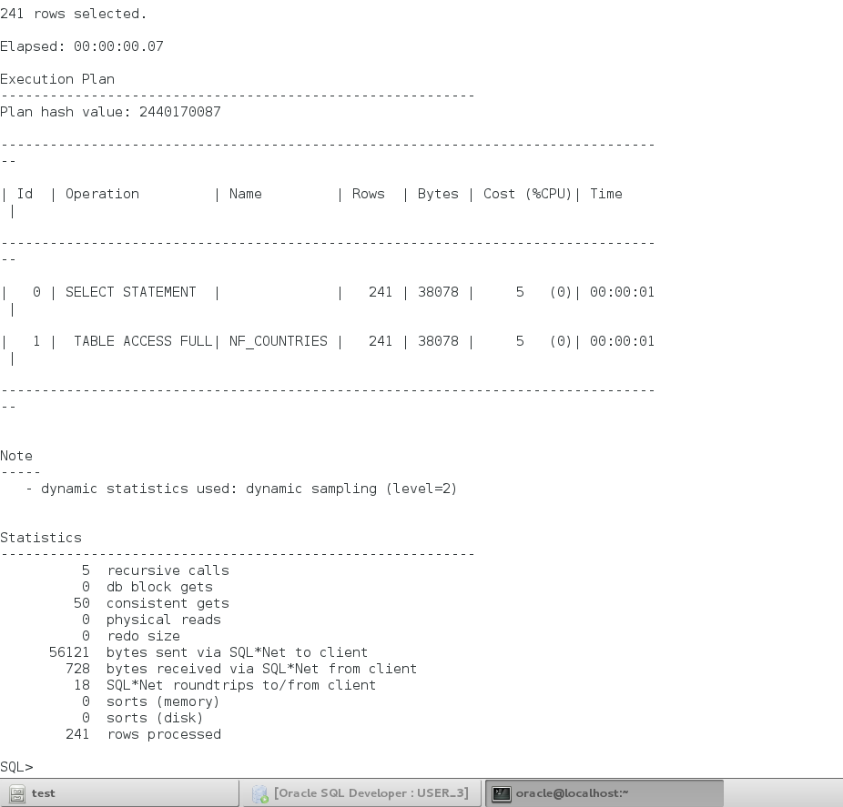

## Running script

Simple select statement was made in SQL Developer and saved in default workplace on Linux. Then in was opened with only @ wildcard in SQL*Plus

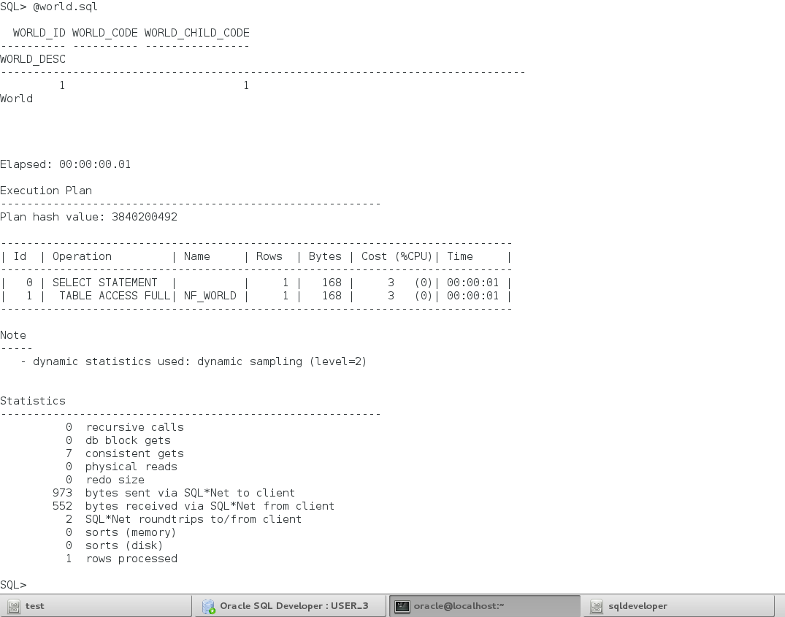

## Save data to file

Spool makes it possible to save data to file:

